IF-CLAUSES

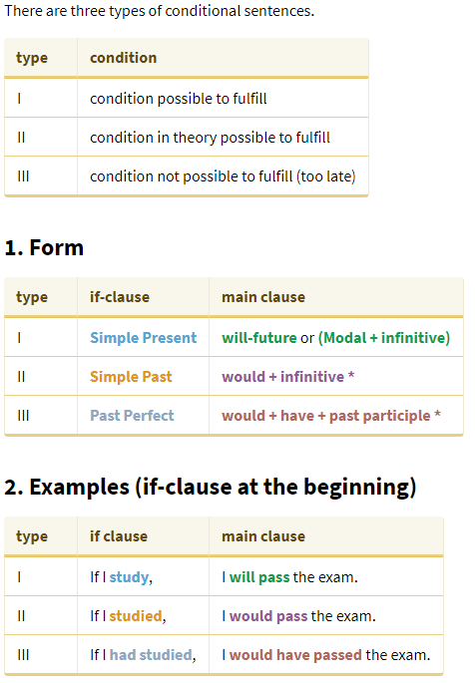

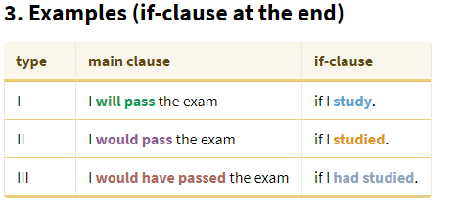

NOW, PRACTISE !

CONDITIONAL SENTENCES TYPE I

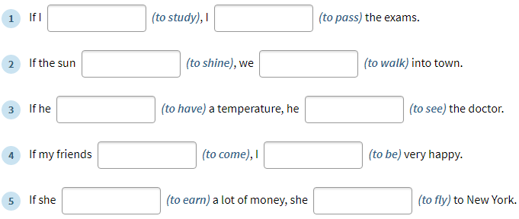
- If I study, I will pass the exams. + (pass an exam = avoir un examen / have an exam= passer un examen)
- If the sun shines, we will walk into town. +
- If he has a temperature, he will see the doctor. +
- If my friends come, I will be very happy. +
- If he earns a lot of money, she will fly to New York. +

CONDITIONAL SENTENCES TYPE II

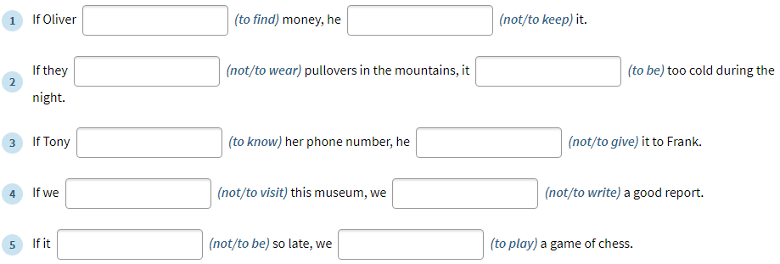
- If Olivier finded money, he would not keep it. +
- If they did not wear pullovers in the mountains, it would be too cold during the night. +
- If Tony knew her phone number, he would not give it to Frank. +
- If we did not visit this museum, we would not write a good report. +
- If it was not so late, we would play a game of chess. +

CONDITIONAL SENTENCES TYPE III

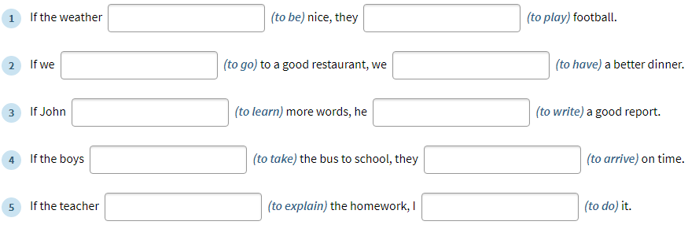
- If the weather had been nice, they would have played football.
- If we had gone to a good restaurant, we would have had a better diner.
- If John had learnt more words, he would have writed a good report.
- If the boys had taken the bus to school, they would have arrived on time.
- If the teacher had explained the homework, I would have done it.

